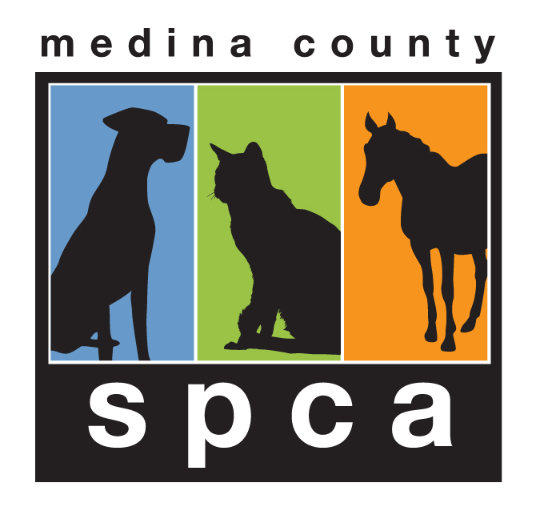
Medina County SPCA
8790 Guilford Road
Seville, Ohio 44273
330-723-7722

ADOPTION AGREEMENT (Small Animal)
(PLEASE WRITE LEGIBLY-WE USE THIS INFORMATION FOR ANIMAL RECORD KEEPING)

Date ____________________

This Agreement is between the Medina County Society for the Prevention of Cruelty to Animals (SPCA), a non-profit Ohio Corporation operating as a County Humane Society pursuant to O.R.C. Chapter 1717, and

Adopter’s Name(s): ______________________________________________________________________

Street Address: ____________________________________________________________________________

City, State and Zip Code: _____________________________________________________________________

Email Address: ___________________________________________________________________

Home Phone: ___________________ Work Phone: __________________ Cell Phone: _____________________

For the adoption of the following breed: Guinea Pig Rabbit Ferret Hamster/Gerbil Other _____________

Name(s) ____________________________________________________ Male Female

Approx. Age/DOB _____________________________ Intake # _______________________________________

TERMS & CONDITIONS

The purpose of this Agreement for both parties is to find a good, permanent, quality home for the above animal(s) consistent with the goals of the Medina County SPCA (referred to as the “SPCA”) to promote humane treatment of animals and to combat pet overpopulation. Parties therefore agree as follows:

1. I hereby accept full responsibility of the above animal(s) upon payment of a non-refundable adoption fee of $____________. I will not sell, give away or otherwise transfer ownership or permanent possession of the
animal to another party without prior written consent of SPCA. If I cannot or am unwilling to keep the animal, it must be returned immediately to the SPCA. I will provide written notice of any change of address or phone
number to the SPCA within 30 days of any such move or change. I will notify the SPCA immediately if the
animal becomes lost. Should I decide to return this pet, I will give at least a 24-hour notice to the SPCA.

2. I understand the SPCA rescues animals from a wide variety of circumstances, including abuse and neglect. Although SPCA personnel may provide me with some information about the animal, the SPCA can never guarantee the health, behavior or disposition of the animal. Therefore, I take ownership of the animal “As Is” and “With All Faults”. Should I choose to, I can have the animal examined prior to adoption by a veterinarian or animal specialist of my choice. I understand this animal could be harboring an illness and therefore agree it is best to keep this new pet separated from my other pets for a period of 7 days to prevent the possible spread of illness to the other animals in my home. I further agree the SPCA is not responsible for any expenses incurred for any animal in my home including the animal I would like to adopt once the adoption process is complete.

3. I agree to provide excellent care for this animal for its lifetime, including but not limited to the following:
a. I will keep this animal as an indoor pet (unless written permission is given by a Director).
b. I will provide fresh water at all times and quality food.
c. I understand the SPCA suggests all adopters take their new pet to a veterinarian within 10 days.
d. I agree not to have cosmetic surgery on the adopted animal.
4. I agree to not breed this pet.

5. Members of the SPCA may make periodic home visits to check on this animal for the purpose of confirming
compliance with this Agreement. I will cooperate in making this animal and its home available to them upon request.

6. If I fail to strictly comply with the above paragraphs or if I am charged with or convicted of an offense relating to animal cruelty, neglect or abandonment, ownership of the animal shall immediately revert to the SPCA; and I must immediately return the animal. The SPCA thereafter shall have the right, but not the obligation, to enter my premises without further notice to retrieve the animal, and such entry shall not be deemed a trespass. I will immediately pay the SPCA $15 liquidated damages (not as a penalty) for each day I fail to return the animal under this paragraph. I agree that $15 per day is reasonable compensation for depriving the SPCA of its property and disrupting the purpose of this Agreement to provide a secure, stabile, permanent home for the animal, and that the actual damages would be difficult to determine.

7. I will indemnify and hold harmless the SPCA against all liability and claims for losses and damages to me, my family and other persons or property in connection with the animal, including but not limited to damages from animal bites/attacks and claims of negligence on the part of the SPCA. I hereby waive any remedy for damages which is not specifically contained in this Agreement. In the event of legal action arising from this Agreement, the losing party shall pay the prevailing party’s costs and attorney fees, whether incurred prior to or after legal action is filed.

8. This document shall be deemed a transfer of ownership certificate if the subject is a dog, pursuant to R.C.955.11(B). This Agreement is the entire understanding between the parties. The parties are not relying on any prior communication of any kind. This Agreement shall be governed by Ohio law. Any action to enforce or interpret this Agreement must be made in the appropriate court with jurisdiction in Medina County, Ohio.

I (We) have read, understand and agree to all of the above provisions relating to the adoption of this animal

Date: ________________________

______________________________________
Adopter(s) Signature

______________________________________
MCSPCA/Store Associate Signature

